Hand Print Tree Craft with Tissue Paper and Buttons

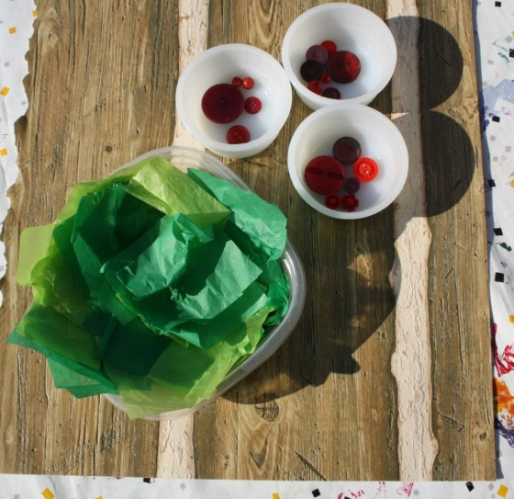

To make your handprint tree craft you will need:
Textured paper
Tissue paper
Buttons
Glue
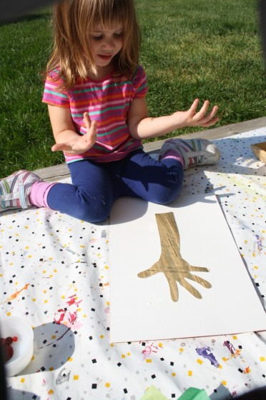

We traced their arms and hands on some groovy wall paper samples that look just like wood. The tracings became the trunks and branches of the trees.
Add your tissue paper leaves: crumple up squares of green tissue paper to form the leaves of the tree.

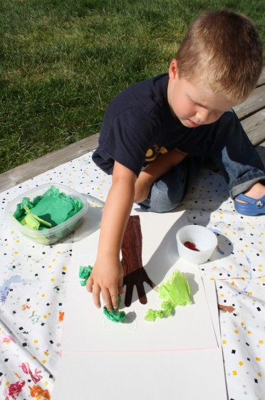

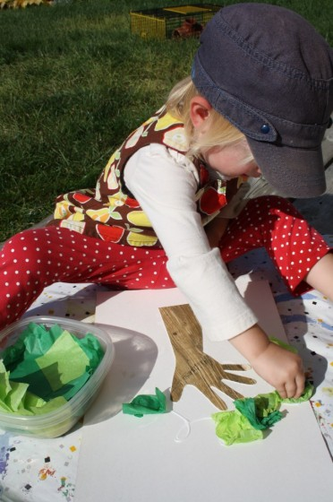

If making a fruit tree, add colored buttons for fruit:

